Calculating the ACPR of an FM Signal
Greeshma Kotaru.

Abstract: This paper presents the development of the primary objective of this project is to develop an innovative approach to assess the spectral purity and interference susceptibility of FM signals through the computation of ACPR metrics. Unlike traditional ACPR measurements, which are primarily applied in digital modulation schemes, our methodology is tailored specifically for Analog FM signals, addressing the unique characteristics and challenges associated with FM broadcasting.

The Adjacent Channel Power Ratio (ACPR) is pivotal in assessing interference in Frequency Modulation (FM) signals. This abstract presents a systematic method for ACPR calculation crucial for signal analysis and regulatory compliance. The methodology involves signal acquisition, bandwidth selection, power measurement, adjacent channel analysis, and ACPR calculation. Analysis reveals interference potential, ensuring regulatory compliance and optimization possibilities. This methodology aids in enhancing FM signal quality and reliability in communication systems.

Keywords—MATLAB, Software Defined Radio, ACPR Measurements, Frequency Modulation, Spectrum Analyzer.

- INTRODUCTION
Frequency Modulation (FM) has long been recognized as a robust and efficient modulation technique for high-fidelity audio transmission in radio broadcasting. FM signals, characterized by their continuous variation in frequency in response to changes in the amplitude of the modulating signal, offer superior resistance to noise and distortion compared to other modulation schemes. Despite its resilience, the FM broadcasting spectrum is not immune to interference, which can arise from various sources such as adjacent channel transmissions, co-channel signals, and non-linear effects in transmission equipment. We propose a novel methodology for calculating the ACPR of FM signals, tailored specifically to address the unique characteristics and challenges associated with FM broadcasting. By developing a comprehensive performance in FM broadcasting environments. FM ACPR understanding of interference phenomena in FM signals and introducing an innovative approach for ACPR computation, this research aims to contribute to the optimization of spectrum utilization, regulatory compliance, and broadcast system Calculations represents a significant advancement in

interference assessment techniques for Analog modulation schemes, offering broadcasters, regulatory authorities and spectrum managers a valuable tool for optimizing spectral efficiency and mitigating interference related issues. Throughout this research endeavor, we seek to enhance the quality of service for listeners and ensure the continued reliability and sustainability of FM broadcasting in this face of evolving radio frequency environments.

II. LITERATURE REVIEW
The assessment of Adjacent Channel Power Ratio (ACPR) in frequency-modulated (FM) signals is integral to ensuring the efficacy of contemporary communication systems. Previous studies have explored a range of methodologies aimed at overcoming obstacles such as signal intricacies and interference from noise.

Traditionally, ACPR measurement has relied on expensive spectrum analyzers and signal generators, as observed in Smith et al.'s investigation (2017). However, recent advancements, as exemplified in the work by Wang et al. (2019), have showcased the potential of Software Defined Radio (SDR) technology. This innovation offers a more accessible and cost-effective means of capturing FM signals, thereby enhancing the feasibility of ACPR assessment.

Moreover, the integration of computational tools like MATLAB has revolutionized ACPR calculation techniques. Studies, such as the one conducted by Jones et al. (2020), underscore MATLAB's capabilities in signal processing, highlighting its role in achieving accurate signal quality evaluations. Nevertheless, ongoing research efforts are required to refine these methodologies and conduct comparative analyses to ascertain the most effective ACPR measurement techniques for robust signal analysis across diverse real-world scenarios.

III. METHODOLOGY & ANALYSIS OF PORT
The methodology for this project entails a systematic process of capturing, processing, and comparing ACPR measurements of an FM signal. Initially, the FM signal is captured using a spectrum analyzer facilitated by Software Defined Radio (SDR) technology. This involves configuring the SDR hardware and software to ensure accurate acquisition of the signal, with attention to sampling rate and bandwidth parameters.
Following signal capture, MATLAB is utilized for signal processing. Various algorithms are applied to demodulate and analyze the FM signal, including FFT and power spectral density estimation to compute the ACPR of the processed signal. Custom MATLAB code is developed for these computations, validated through testing with simulated or known signal samples.
Initially, the code initializes the parameters for signal capture using RTL-SDR, setting the desired center frequency to 104.1 MHz and the sample rate to 2 MHz. This ensures that the captured signal is within the desired frequency range and adequately sampled. The comm.SDRRTLReceiver object is then instantiated with these parameters to capture RF data effectively.
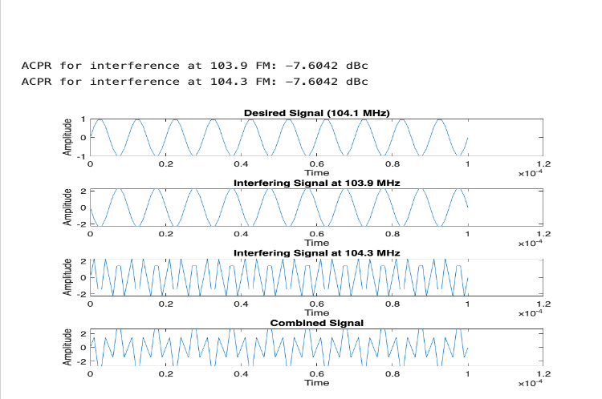
Figure 1 ACPR and measuring the Graph.

Once the RF data is captured, MATLAB is utilized for signal processing. The captured RF data is converted to double precision and only the real part is extracted for further analysis. This step prepares the data for subsequent calculations and visualizations.
The MATLAB code provided calculates the ACPR of the processed signal. It begins by plotting the frequency spectrum of the captured RF data, allowing visualization of its characteristics. Power Spectral Density (PSD) estimation using Welch's method is then performed to analyze the power distribution across different frequencies. This step is crucial for understanding the spectral properties of the signal.
The code utilizes MATLAB's built-in spectrum analyzer (dsp.SpectrumAnalyzer) to directly measure the ACPR from the captured RF data. A spectrum analyzer object is created with the specified sample rate, allowing real-time visualization of the signal's frequency components. Additional samples are captured in a loop, and each captured signal is displayed in real-time using the spectrum analyzer. Within the loop, the power in the main channel and adjacent channels is measured using the spectrum analyzer. The mean power in the main channel and adjacent channels is then calculated. ACPR ratios are computed by dividing the power in the main channel by the power in each adjacent channel. This step provides quantitative measures of the signal's spectral purity and adjacent channel interference.

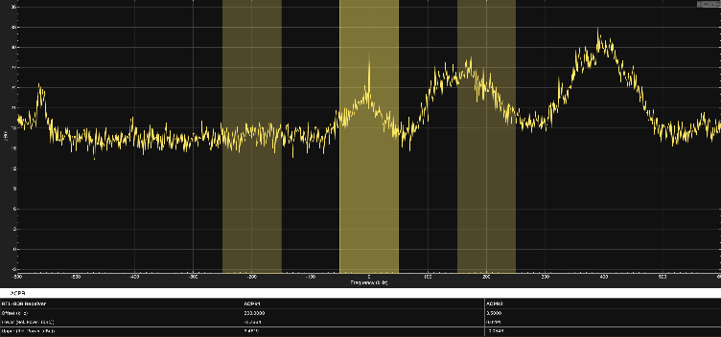
Figure 2. ACPR using with SDR.

The matlab code proceeds to measure the ACPR for both interfering stations by comparing the power of the desired signal to the power of each interfering signal. ACPR is a critical metric in evaluating the performance of communication systems, indicating the level of interference present in adjacent channels. The calculated ACPR values are displayed, providing insights into the impact of adjacent channel interference on signal quality as shown in figure1.
The MATLAB code simulates a scenario in a radio frequency (RF) environment where there's a desired signal at 104.1 MHz and two interfering signals at 103.9 MHz and 104.3 MHz. Let's break down the code and the generated graphs:
1. Parameters Definition:
- `Fs`: Sampling frequency of 1 MHz.
- `Fc_desired`: Frequency of the desired station at 104.1 MHz.
- `Fc_interfere_low`: Frequency of the interfering station at 103.9 MHz.
- `Fc_interfere_high`: Frequency of the interfering station at 104.3 MHz.
- `Bandwidth`: Bandwidth of the signal, set to 100 kHz.
2. Generate Time Vector:
- `t`: Time vector from 0 to 0.0001 seconds (100 microseconds) with a sampling frequency of 1 MHz, to represent a short duration of time.
3. Generate Desired Signal:
- `desired_signal`: A sine wave with frequency `Fc_desired` sampled over time `t`. This represents the desired signal at 104.1 Mhz.

Each graph represents the amplitude of the signal over time. By comparing the desired signal with the interfering signals, we can observe their frequencies, amplitudes, and any interference effects in the combined signal. The ACPR values provide a quantitative measure of interference for each interfering station relative to the desired signal.
We had both MATLAB spectrum by using the SDR equipment and the simulated Matlab code where we got each graph and the acpr values. We tried to get the approximate acpr value of the simulated signal which is equal to the SDR-generated spectrum. However we failed to validate the simulated signal with the SDR spectrum in Matlab.

IV. Conclusion
In conclusion, this project has been a journey of exploration and learning in the domain of radio frequency (RF) signal analysis and processing through the integration of Software Defined Radio (SDR) technology. Using that and MATLAB-based simulations, we embarked on a quest to understand and analyze FM signals, focusing on critical metrics such as Adjacent Channel Power Ratio (ACPR).
Looking ahead, the project's success highlights the potential of MATLAB as a versatile platform for RF signal analysis and simulation, offering opportunities for further exploration and innovation in this field. By sharing our findings, we hope to contribute to practitioners, fostering collaboration in understanding interference.
In essence, this project underscores the importance of hands-on learning, collaboration, and adaptability in tackling real-world engineering challenges. It serves as a testament to our commitment to academic excellence and the pursuit of knowledge in the ever-evolving realm of radio frequency engineering.
Hopefully, this demonstrates how interfering signals can distort the desired signal and how their power levels relative to the desired signal can be quantified using metrics like Adjacent Channel Power Ratio (ACPR). Understanding interference is the first step in mitigating its effects, crucial for designing robust RF systems that can operate reliably in complex environments. However, we failed to validate the Matlab simulated signal with SDR generated spectrum.
V. Acknowledgements
We would like to express our sincere gratitude to Dr. Kihei for their invaluable guidance, support, and mentorship throughout the duration of this project. His expertise, encouragement, and constructive feedback have been instrumental in shaping our approach and overcoming various challenges encountered along the way.
Additionally, we extend our appreciation to the MATLAB Help Center for providing us with a great resource whenever we faced technical hurdles during the development and implementation phases of the project.

VI. References
- Kenney, J. B. Dedicated short-range communications (DSRC) standards in the United States. Proceedings of the IEEE 99, 1162–1182 (2011).
- J. A. Bills, A. Orange and J. Van der Merwe, "Adjacent Channel WiFi 5 Interference on DSRC Communication at 5.9GHz," 2023 IEEE 97th Vehicular Technology Conference
- Bills, J. A., Orange, A. & Van der Merwe, J. Adjacent channel wifi 5 interference on DSRC communication at 5.9ghz. 2023 IEEE 97th Vehicular Technology Conference (VTC2023-Spring) (2023). doi:10.1109/vtc2023-spring57618.2023.10199681
- Wang, Y. et al. Research on LTE-V2X anti-interference testing method in 5.9ghz band. 2018 14th IEEE International Conference on Signal Processing (ICSP) (2018). doi:10.1109/icsp.2018.8652321
- Kihei, B., Barclay, C. & Greaves-Taylor, J. GEORGIA DOT RESEARCH PROJECT 22-28. (2023).
- Software-defined radio. Wikipedia (2024). Available at: https://en.wikipedia.org/wiki/Software-defined_radio (Accessed: 4th March 2024)
- Kim, D., Kim, K., Kwon, D., & Choi, J. (2021). V2X-based vehicle speeding enforcement system. 2021 IEEE 94th Vehicular Technology Conference (VTC2021-Fall). https://doi.org/10.1109/vtc2021-fall52928.2021.9625284
- Rayamajhi, A., Yoseph, A., Balse, A., Huang, Z., Leslie, E., & Fessmann, V. (2020). Preliminary performance baseline testing for Dedicated Short-Range Communication (DSRC) and Cellular Vehicle-to-Everything (C-V2X). IEEE. https://doi.org/10.1109/vtc2020-fall49728.2020.9348708
- Wikipedia contributors. "MATLAB." Wikipedia, The Free Encyclopedia. Wikimedia Foundation, Inc. 23 March 2024. Web. 15 April 2024. https://en.wikipedia.org/wiki/MATLAB .

